**Infocomm Sales and Marketing**

Year 2/3 (2024), Semester 3/5

**SCHOOL OF INFOCOMM TECHNOLOGY**

Diploma in Information Technology

Diploma in Data Science

**ASSIGNMENT 2 Individual Report**

|  |  |  |
| --- | --- | --- |
| **Tutorial Group** | **:** | DS-01 |
| **Student Name** | **:** | Tan Jun Yu Zavier |
| **Student Number** | **:** | S10255651D |

**Table of Contents**

1. Introduction 2

2. Preview 2

3. Objective 2

4. App Development using PartyRock 4

4.1 Design Mocks of the App 4

4.2 Promotional Technique 5

4.3 Rationale & Purpose for Snap4Biz 5

5. Reflection on Using PartyRock as a GenAI tool 6

6. Comparison with other GenAI Tool 7

7. Feedback 9

8. Self-Reflection for Group Report 11

# **Introduction**

As part of my assignment and in conjunction with the guest sharing by AWS on the use of Gen AI tools including PartyRock for development of apps, I have been tasked to build an app using PartyRock as part of the marketing strategy for the company I chose Snap Inc. on Snapchat, under one the 4 Ps, ‘Promotions’.

So, I have created an app to help promote the array of features Snapchat has to offer by educating business on how to leverage it: Snap4Biz Consultation App

# **Preview**

The Snap4Biz app is to promote Snapchat as a powerful marketing platform for businesses, especially startups and small to medium-sized enterprises (SMEs). By demonstrating the various features and tools Snapchat offers, Snap4Biz aims to showcase how businesses can effectively utilize these resources to enhance their marketing and promotional activities.

# **Objective**

* **Promote Snapchat’s Capabilities:** To highlight the diverse tools and features available on Snapchat, such as Stories, Geofilters, Lenses, and Snap Ads, and demonstrate how these can be used to drive brand visibility and engagement.
* **Educational Resource:** To educate businesses on the best practices for using Snapchat in their marketing strategies, providing them with the knowledge and confidence to leverage the platform effectively.
* **Strategic Guidance:** To offer strategic advice on integrating Snapchat into broader marketing campaigns, including tips on content creation, audience targeting, and performance measurement.

# **App Development using PartyRock**

Snap4Biz App Link: <https://partyrock.aws/u/Zavier/nZyxCUlSK/Snap4Biz-Consulting-App>

# **Design Mocks of the App**

# **Promotional Technique**

Based on the promotion tool table, I used the sales promotion tool when creating the app.

**Reach**

The specific segment I had in my when building the app was targeted towards startups and small to medium-sized enterprises (SMEs). The app is meant to provide businesses comprehensive educational resources about using Snapchat for business. This includes detailed guides, best practices, and strategic advice. The educational approach is rooted in content marketing, aimed at providing value to users and positioning Snapchat as an essential tool for their marketing needs.

**Main Costs**

Creating the Snap4Biz app was relatively cost-effective due to it being preloaded with many useful resources for app creation. This approach minimized development costs while maximizing the value provided to the target audience.

**Strengths**

One of the main strengths of the Snap4Biz app is its flexibility. The app can be easily adjusted and updated to include new features as Snapchat evolves. This adaptability ensures that the app remains relevant and valuable to its users over time.

**Weaknesses**

However, the free nature of the platform means that many others have access to the same resources, making it easy for competitors to recreate or even improve upon the app. Additionally, the use of AI poses a risk, as individuals with malicious intent could provide false or misleading information under the guise of a trustworthy guide. The ease of app creation also means there will always be constant competition, which can dilute the app's unique value proposition.

# **Rationale & Purpose for Snap4Biz**

In the fast-paced VUCA world, it is increasingly important to provide businesses with comprehensive tools that can streamline their promotional efforts and maximize engagement. The idea for Snap4Biz was conceived specifically to assist startups and small to medium-sized enterprises (SMEs) in effectively leveraging Snapchat for their marketing needs. The goal was to offer an educational and strategic resource that simplifies the process of using Snapchat’s diverse tools for business promotion.

Snap4Biz was inspired by the challenge many businesses face in understanding and utilizing social media platforms efficiently. Creating impactful content and campaigns often requires significant manual effort and expertise, which can be daunting and inconsistent, especially for smaller businesses. Moreover, each platform has its unique set of features and user behaviour, adding another layer of complexity. Snap4Biz was designed to address these challenges by providing detailed guides, best practices, and strategic advice tailored to Snapchat, allowing marketing managers to focus more on creative strategy and execution.

When developing Snap4Biz, several key considerations were kept in mind to meet the needs of Snapchat's business users. The primary focus was on **educational value**. Snap4Biz provides comprehensive resources that educate users on the various features of Snapchat, such as Stories, Geofilters, Lenses, and Snap Ads, and how to use them effectively for marketing purposes. This helps businesses quickly learn and implement these tools, keeping pace with market trends and user behaviour.

**Consistency** was another critical factor. Maintaining a unified brand voice across all marketing efforts is crucial for building brand identity and trust. Snap4Biz offers step-by-step instructions and best practices to ensure that businesses create content that aligns with their brand guidelines, ensuring a cohesive and professional presence on Snapchat.

**Efficiency** was a final key consideration. Snap4Biz aims to reduce the time and effort required to develop effective Snapchat campaigns by offering ready-to-use templates and detailed tutorials. This enables businesses to produce high-quality content quickly, ensuring they remain agile and responsive to market demands.

As Snapchat continues to evolve and grow, the ability to scale content creation becomes increasingly important. Snap4Biz supports this by equipping businesses with the knowledge and tools to generate large volumes of engaging content without compromising on quality. This is essential for keeping up with the platform's dynamic nature and ensuring that promotional efforts are always fresh and compelling.

Overall, Snap4Biz was developed to enhance the capabilities of Snapchat's business users by providing an all-encompassing, educational, and strategic tool. It helps businesses produce consistent, customized, and high-quality content efficiently, allowing them to focus more on creativity and strategic planning.

# **Reflection on Using PartyRock as a GenAI tool**

When I first came across PartyRock, it was during the AWS Guest sharing session led by John Fan on June 26th, 2024. My initial thought when using PartyRock to create an app was smooth and intuitive, even as a user who never used it before. The user interface stood out as simple and straightforward. This allows generating a base app easy, as PartyRock allows for direct input of app ideas. Although some time was needed to familiarize myself with the widgets and how to integrate them, the learning curve was fairly manageable.

The fundamental functionalities of PartyRock were quickly grasped. One of the standout features of PartyRock compared to other GenAI tools is its efficiency with minimal input. Unlike tools like OpenAI and Claude, which require detailed context and numerous sentences to generate the desired content, PartyRock operates effectively with just a few inputs on various widgets. This efficiency significantly reduces the time needed to produce content, making the tool exceptionally user-friendly and timesaving.

Overall, my experience with PartyRock highlighted its strengths in simplicity and efficiency. The tool's design allows for quick learning and application, making it an ideal choice for businesses looking to streamline their content creation process. By reducing the complexity typically associated with GenAI tools, PartyRock enables users to focus more on strategic planning and creativity, ultimately enhancing their marketing efforts.

# **Comparison with other GenAI Tool**

Here I will be showing some comparison by using the same prompt to compare the output between selected AI tools and Snap4Biz Consultation App.

# Prompt: I would like to learn more about the features of Snapchat Lenses.

**ChatGPT Response**

**Gemini Response**

**Snap4Biz Response**

As you can see, when entering the same prompt on ChatGPT and Gemini, the response is quite similar and lacking any depth in the quality it produces. However, with Snap4Biz, it does not only tell you about the feature you want to know more about. But it goes above and beyond to provide you with examples, scenarios and strategies on how the user can leverage on the features to help them in their business planning. The content is more personalized to allow users to feel that the AI is not just providing suggestions, but recommending suggestions alongside them with the context that they are business owners wanting to leverage on these tools. So, it works alongside them understand the business context and how the features from Snapchat can apply and help in their business needs. Snap4biz also ensures that the information provided is reliable and accurate as it at least searches from 5 authoritative sources and ensure the information is similar before recommending to users. It also shows where they get the information down by showing the sources from unlike ChatGPT and Gemini. This helps users to trust Snap4biz more and differentiates itself from the other 2 by being reliable, accurate and informative. Making reading and understanding concepts and strategies easier than before.

# **Feedback**

Once the app was done, I created a google form to gather constructive feedback on the app. Here are the statistics.

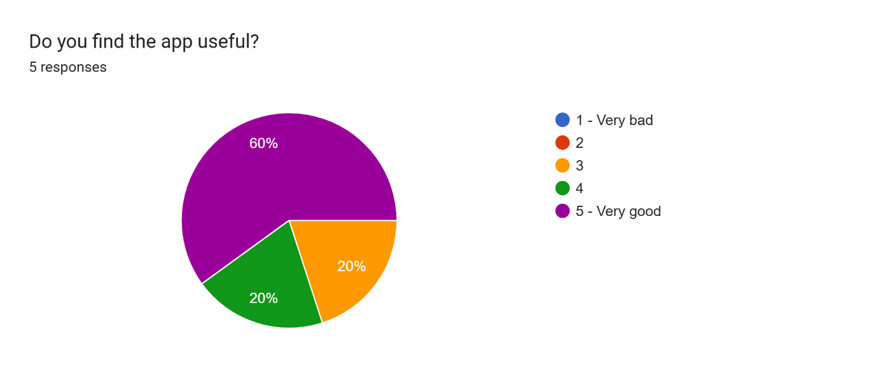

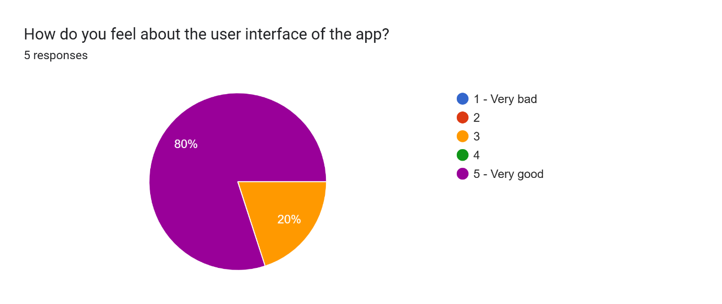

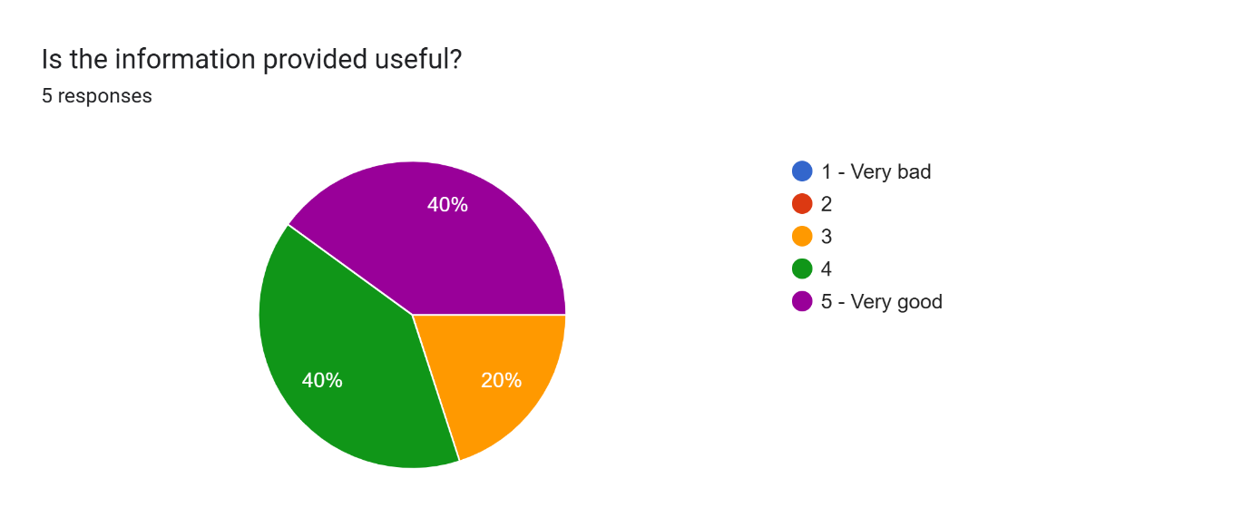

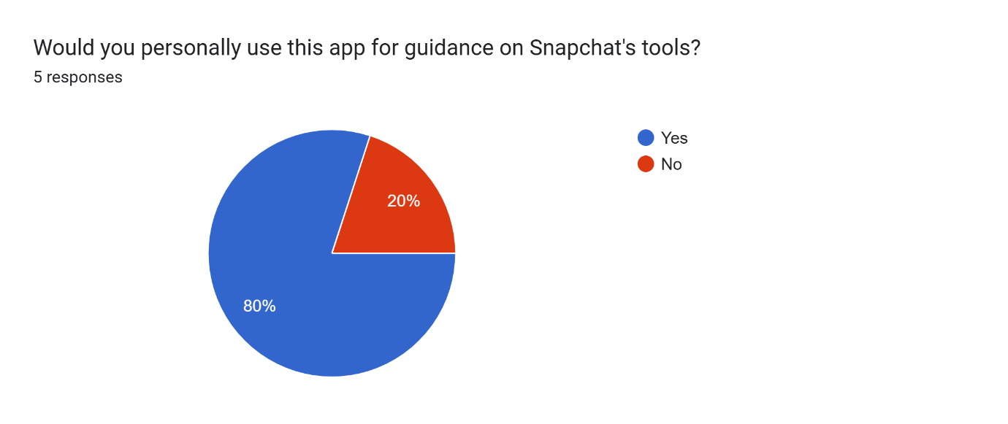

The survey results on the Snap4Biz app reveal a nuanced perspective from its users. The majority find the app itself quite useful, with 60% rating it as very good and another 20% giving it a moderate score. However, sentiments about the user interface are more positive, with 80% considering it very good, suggesting a strong appreciation for its design and functionality. The quality of the information provided, critical for such a tool, shows a split view: 40% find it very good, yet another 40% only rate it moderately, highlighting an area for improvement. Despite these critiques, a significant 80% of respondents would personally use the app for guidance on Snapchat's tools, indicating a strong overall approval and perceived utility of the app in leveraging Snapchat for business needs. This suggests that while there are areas for enhancement, particularly in making the provided information more valuable, the app's core functionality and interface are well-received.

# **Conclusion**

Going through the group report, I have learned quite a lot such as expanding my domain knowledge within the Social Media Industry, keeping up with past and present events within the industry and learn the various reasons why certain factors can impact a company of such a big scale like Snap Inc. In addition to that, I have learned more of Snap Inc history and how it has come a long way competing with relatively bigger companies like Meta which owns Facebook and Instagram and Twitter X.

While doing the group report, the use of AI tools was crucial to save time and ensure efficiency. However, we also needed to determine if the information provided by the AI tools were accurate. We made sure the prompts we entered were clear and detailed, such as giving the AI enough context to know what answer we are trying to seek and making sure it provides the source links from where it extracted the information out so human intervention like checking if the information is reliable and accurate.

To share more of my personal experience navigating my way when researching the social media industry and Snap Inc, at times I receive different inputs from the different AI tools used. With some providing information with source links included and some not being able to, some being constantly repetitive or even hallucinating, or some based off on the knowledge it got without any source to link to the facts. There have been a constant mix of responses, making it hard to tell which AI tool is telling the more accurate information.

Firstly, I ask the AI to provide me with the source links to determine where the information comes from. When I am sceptical of the information provided, I do fact check by searching it online to check if any articles can relate or confirm the information. Nonetheless, I do read up on the articles found on various website or news outlet to expand my domain knowledge of the social media industry to ascertain if the information is relevant or inaccurate.

Secondly, using some of the prompt engineering skillsets that I have picked up externally, I gave the AI better context, specific instructions and conditions to narrow the response so that the output when produced is more specific and accurate, one way to ensure the AI is not hallucinating or providing irrelevant/inaccurate information is by iterating the main context and constant memory update, when providing the information, I prompt to provide into the PEEL format (Point, Explanation, Example, Link) to ensure that it is able to clearly explain the information provided, which helps to increase result accuracy and better output performance across the AI tools I used.

All in all, with the techniques used and the constant reminder to myself that some AI tools have a knowledge cut-off date. I was able to leverage on the AI Tools and utilize them ethically to provide as much accurate information as possible, as well as intervening using human judgment to determine if it make senses. Therefore, the ability to do self-research by looking up on the internet and the help of AI tools allowed me to provide the best version of the answer.

# **Reflection on using GenAI for Group Report**

Here is an example:

A prompt used to help answer one of the questions in the group report.

**Where is Snapchat placed within the BCG model currently?**

AI Tools Chosen for cross-validation

1. OpenAI’s ChatGPT 4.0

2. Claude

3. Google Gemini

4.Microsoft Co-pilot

ChatGPT Response

Claude Response

Gemini Response

Microsoft Co-pilot

I further prompt the three AI Tools with this prompt message

“Provide me the sources where you extracted the information from?”

ChatGPT response

Claude Response

Gemini Response

**Final Verdict**

**ChatGPT:** When putting in the first prompt, it was able to provide information related to my question. However, based on my findings and the other outputs produced by Claude and Gemini, the answer ChatGPT provided is by far the furthest away from our conclusion on the placement of Snap Inc. within the BCG model. When putting the second prompt, it was unable to provide me any concrete evidence to back up the information it provided. Hence, human intervention was needed and cross checking with the other 3 AI Tools I have chosen to ascertain if the information was true.

**Claude:** When putting in the first prompt, same as ChatGPT it was able to provide information related to my question. This time round, based on my findings and the output produced by Gemini, the answer Claude gave was like our conclusion on the placement of Snap Inc. within the BCG model. However, when putting the second prompt, it was also unable to provide me any concrete evidence to back up the information it provided. Hence, human intervention was needed and cross checking with the other 3 AI Tools I have chosen to ascertain if the information was true.

**Google Gemini:** When putting in the first prompt, same as ChatGPT and Claude, it was able to provide information related to my question. Similarly, it provided answer like what Claude provided on the placement of Snap Inc within the BCG model. However, when putting the second prompt, it was also unable to provide me any concrete evidence to back up the information it provided. Hence, human intervention was needed and cross checking with the other 3 AI Tools I have chosen to ascertain if the information was true.

**Microsoft Copilot:** When putting the first prompt, same as ChatGPT, Claude and Gemini, it was able to provide information related to my question. Similarly, it provided answer like what Claude and Gemini provided on the placement of Snap Inc within the BCG model. The second prompt was not needed as co-pilot automatically provides the links to where it gets the information from. Hence, slight human intervention is required by just checking to ensure the information is valid, otherwise it performed better than the other 3 AI Tools.